*PROGRAM – 27*

**Q : 27.** **C Program to print contents of file.**

***Algorithm for Opening and Reading the text file***

* **For opening a text file**

1. **Start**
2. **Declare variable and file pointer**
3. **Assign file pointer to *fopen()* function with write format**
4. **If file is not opened, print error message**
5. **Else give the content using loop**
6. **Close the file**
7. **Stop**

* **For Reading a Text File**

1. **Start**
2. **Declare variables and file pointer**
3. **Open the file**
4. **If the file is not opened print error massage**
5. **Print the content of the text file using loop**
6. **Close the file**
7. **Stop**

**FLOW CHART :-**

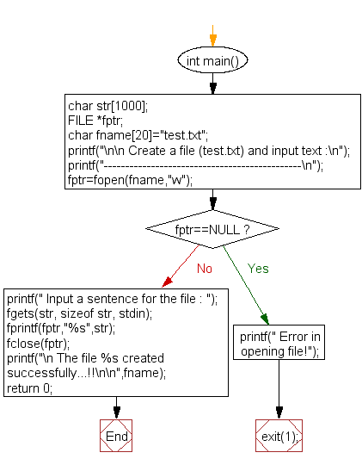

**PROGRAM :-**